Adolfo T. Javier León 2614 Computer Forensics
Phase II
- Target System Description
  - VirtualBox:
    - The target system being used is a local VirtualBox VM for forensic acquisition practice.
  - OS version:
    - Kali Linux (VirtualBox VM)
  - Purpose of the target:
    - The purpose of the VM is to create a simulated controlled environment for forensic acquisition techniques. Since it's used for educational purposes, it's safe for testing without affecting the host
      - Disk imaging
      - Hash Verification
      - Network Traffic Capture
  - Simulated incident scenario:
    - A simulated event introduced to justify forensic acquisition.
      - Suspicious network activity
      - Abnormal system behaviors
      - Unknown files appearing on the system
- Acquisition Plan
  - What data will be collected
    - Full disk image of the target VM
    - Network traffic captures during simulated activity
  - Tools selected (from Phase 1)
    - Guymager
      - Its ability to create forensic-grade disk images with built-in MD5/SHA256 hashing, logging, and integrity verification.
    - Gparted
      - Used to safely identify the correct target disk before imaging. Prevents accidental overwriting and ensures accuracy.
    - Wireshark
      - It's an industry-standard packet analyzer that is used to capture live network traffic and save PCAP files for later analysis.
- Step-by-Step Acquisition Procedures
For each acquisition type:
  - Disk Imaging
    - Commands used
      - Sha256sum image.raw
      - Md5sum image.raw
    - Screenshots
      - Gparted disk identification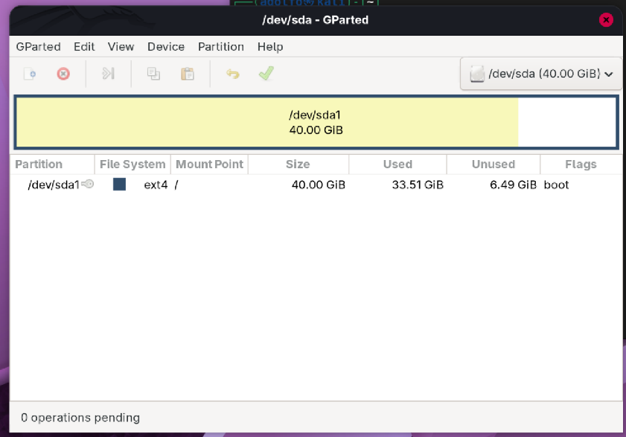
      - Guymager acquisition window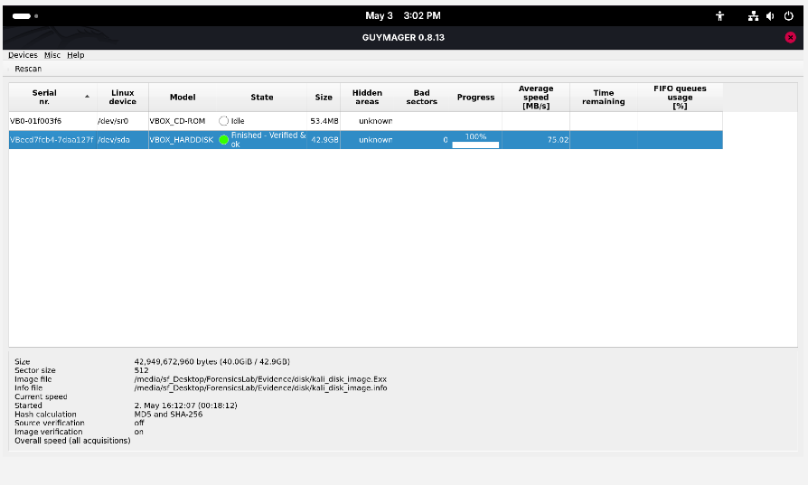
    - Hash values
      - MD5
        - 82a022bfed3fff6800693947f058378f
      - SHA256
        - f60bba51c5e743c41eac77c8af068df3257de53fd5ac71686bf1cb98739ab992
    - File sizes
      - The E01 image consists of multiple segments totaling 42.9 GB
    - Storage location
      - /media/sf_Desktop/ForensicsLab/Evidence/disk/
    - Summary
      - Guymager generated and verified the MD5 and SHA-256 hashes for the image, making the acquired data match the main disk. The results of the image segments and metadata files are stored in the shared evidence directory.
  - Network Traffic Capture
    - Commands used
      - Sudo Wireshark
      - Ping -c 4 youtube.com
    - Screenshots
      - Wireshark capturing traffic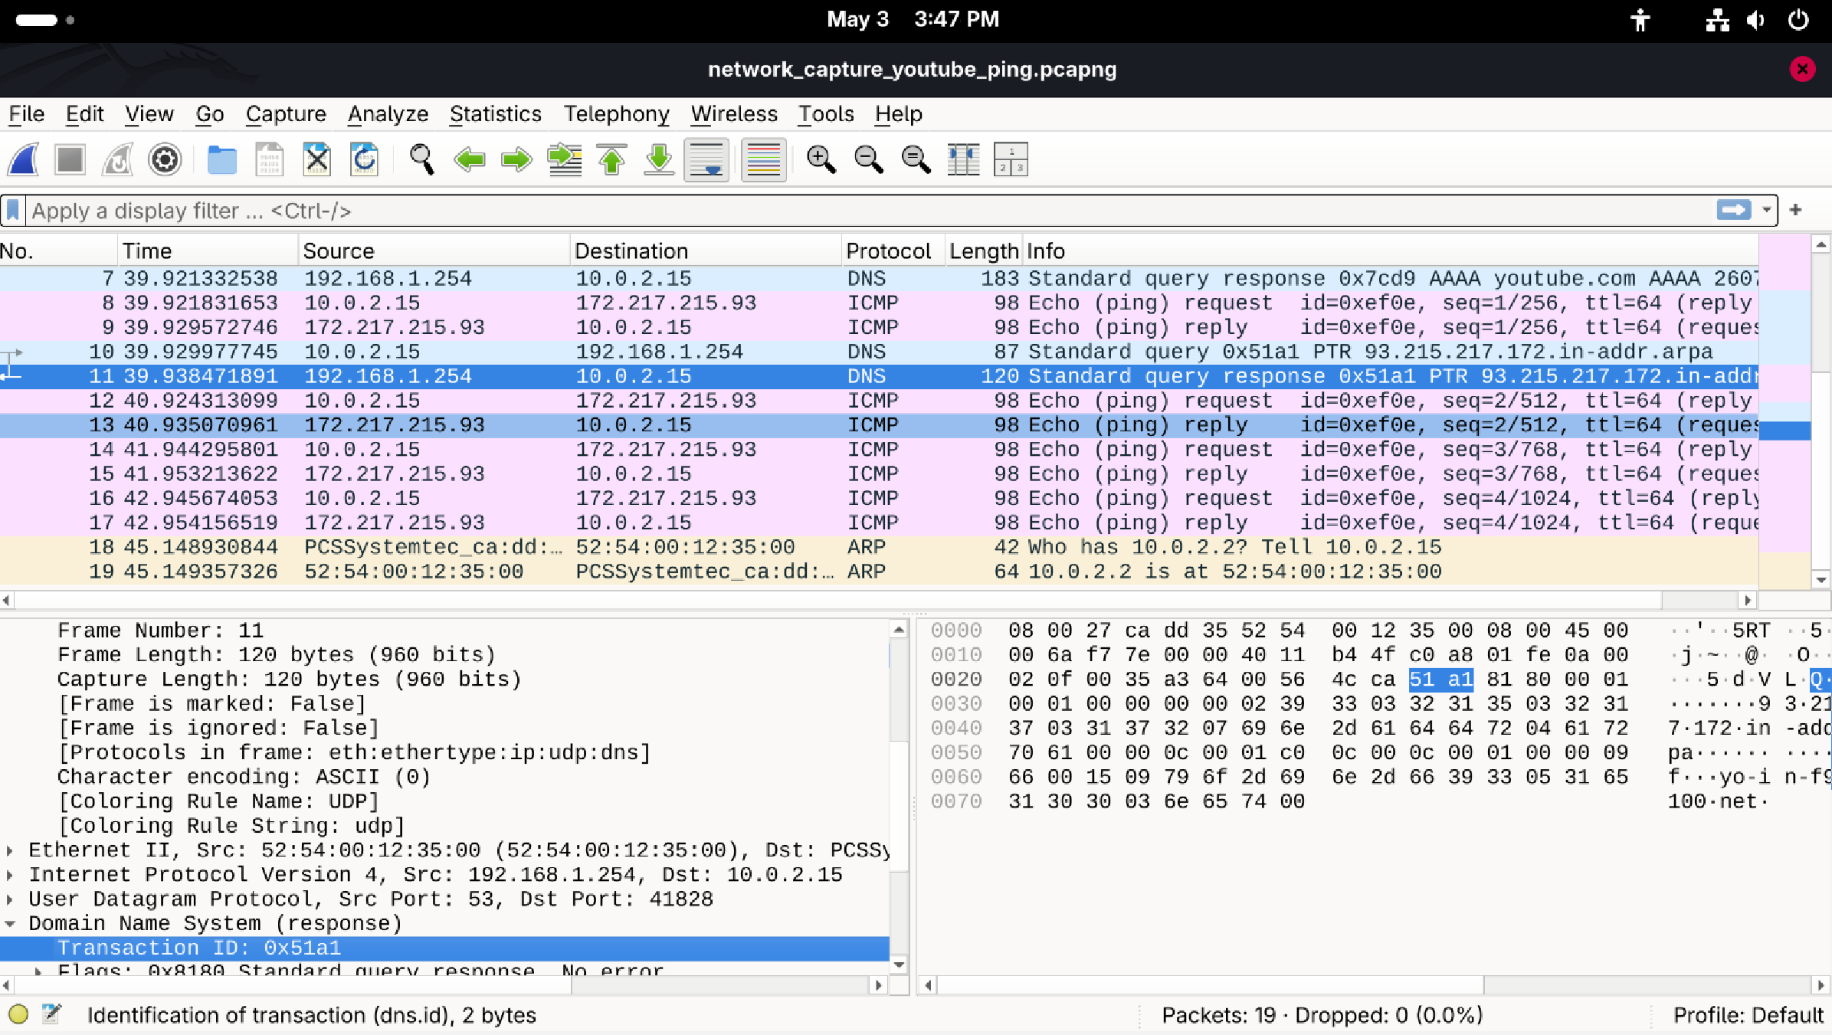
      - Saving the PCAPNG file 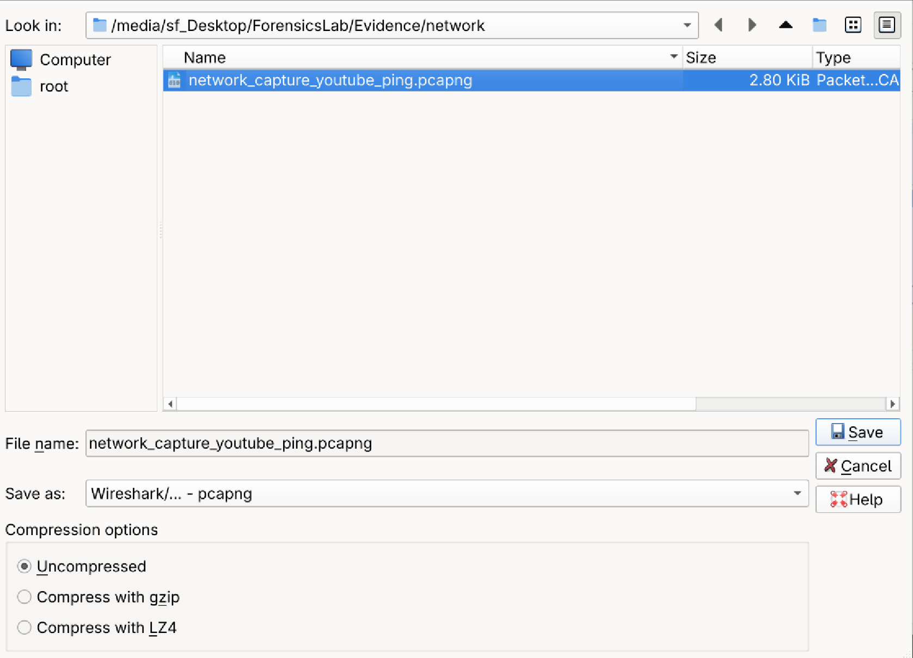
    - File sizes
      - The size of the network_capture_youtube_ping.pcapng totals to 2.80 KiB.
    - Storage location
      - /media/sf_Desktop/ForensicsLab/Evidence/network/
    - Summary
      - A controlled network capture was performed using Wireshark on interface eth0. The capture recorded:
        - DNS resolution
        - ICMP traffic generated by executing the ping
      - The capture was saved as
        - network_capture_youtube_ping.pcapng

- Challenges and Mitigation
  - Technical issues
    - Challenge
      - The VM disk wasn’t visible at first in Guymager, prompting me to correct the storage devices attached to the image
    - Mitigation
      - Verified VirtualBox storage settings and ensured the disk was attached and recognized
  - Permission or access problems
    - Challenge
      - Wireshark displayed the message “You don’t have permission to capture on local interfaces”, making it complicated to packet capture the eth0.
    - Mitigation
        - Issue resolved by going directly to the root to grant permission access, by launching Wireshark through the terminal, and using: Sudo Wireshark.
  - Tool limitations
    - Challenge
      - Guymager displayed an “insufficient free space” warning when first attempting to save the E01 image. This happened in the original destination directory, which didn’t have enough space. The warning prevented the image process from continuing and required changing the storage location before proceeding.
    - Mitigation
      - Verified and confirmed that the new directory had available storage to start the image compression for the E01 segments. After switching to the new directory, the acquisition was restarted, and the image process was completed successfully with no errors
- Chain of Custody Documentation
  - Evidence ID
    - E01
    - NC01
  - Date/time of acquisition
    - 05/03/26
    - 05/03/26
  - Hash verification
    - Disk Images E01
      - MD5
        - 82a022bfed3fff6800693947f058378f
      - SHA256
        - f60bba51c5e743c41eac77c8af068df3257de53fd5ac71686bf1cb98739ab992
    - Network Capture NC01
      - PCAPNG, N/A
  - Storage and handling notes
    - Evidence was stored in read-only directories and handled according to forensic best practice
      - Disk Image
        - /media/sf_Desktop/ForensicsLab/Evidence/disk/
          - Kali_disk_image.E01
          - Kali_disk_image.E02
          - Kali_disk_image.E03
          - Kali_disk_image.E04
          - Kali_disk_image.E05
          - Kali_disk_image.E06
          - Kali_disk_image.info
      - Network Capture NC01
        - /media/sf_Desktop/ForensicsLab/Evidence/network/
          - network_capture_youtube_ping.pcapng
- Summary and Reflection
  - What worked well
    - Guymager successfully created a forensic disk image of the Kali VM, including automatic MD5 and SHA-256 hashing. The tool verified the integrity of the acquisition, and all E01 segment files were stored without corruption.
    - Wireshark captured network traffic effectively on eth0, recording both DNS resolution and ICMP packets generated by the ping command. The capture was saved as a PCAPNG file in the evidence directory.
  - What needs improvement
    - Accessing Wireshark with permission rather than using Sudo, which slowed down the process. Setting up the permissions beforehand would make it smoother and more efficient to access it.
  - How this prepares them for Phase 3 (analysis)
    - The disk image and network capture collected in phase II will serve as a foundation for phase III. These artifacts will be analyzed using tools such as Volatility, Wireshark, and SQLite Browser to identify system activities, network behavior, and potential threats.
    - Completing the phase reinforces the importance of proper evidence handling, hashing, and maintaining a clear chain of custody, which are all essential skills for forensic analysis.
    - The challenges encountered during this phase provided me with hands-on experience with real-world troubleshooting issues, such as resolving permission issues, storage limitations, and more. These experiences prepare me for what comes next in phase III, where more detailed analysis work will be required.

